Implement Tracing in LangFuse for BM25 Search, Re-ranking and Hybrid Search using Vibe Coding
Created the Architecture.md file using vibe coding
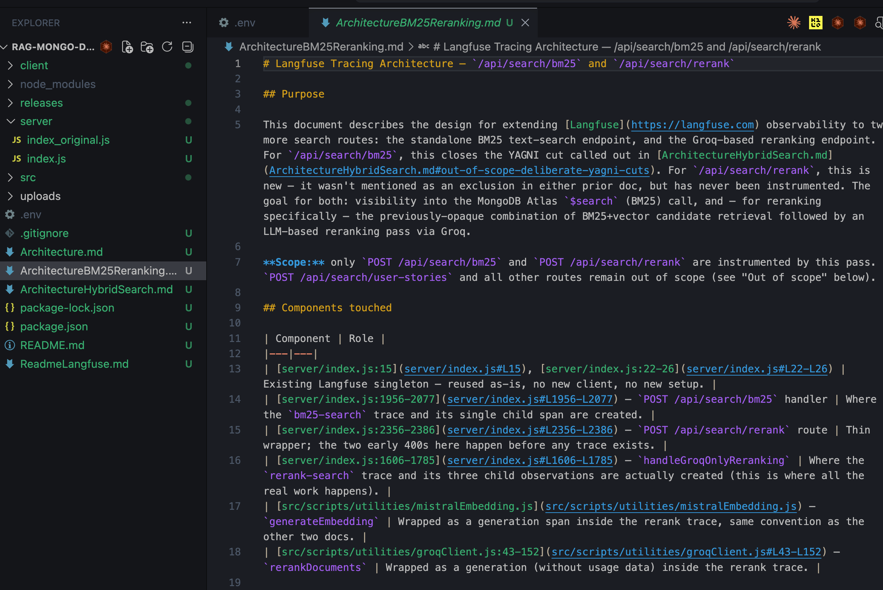
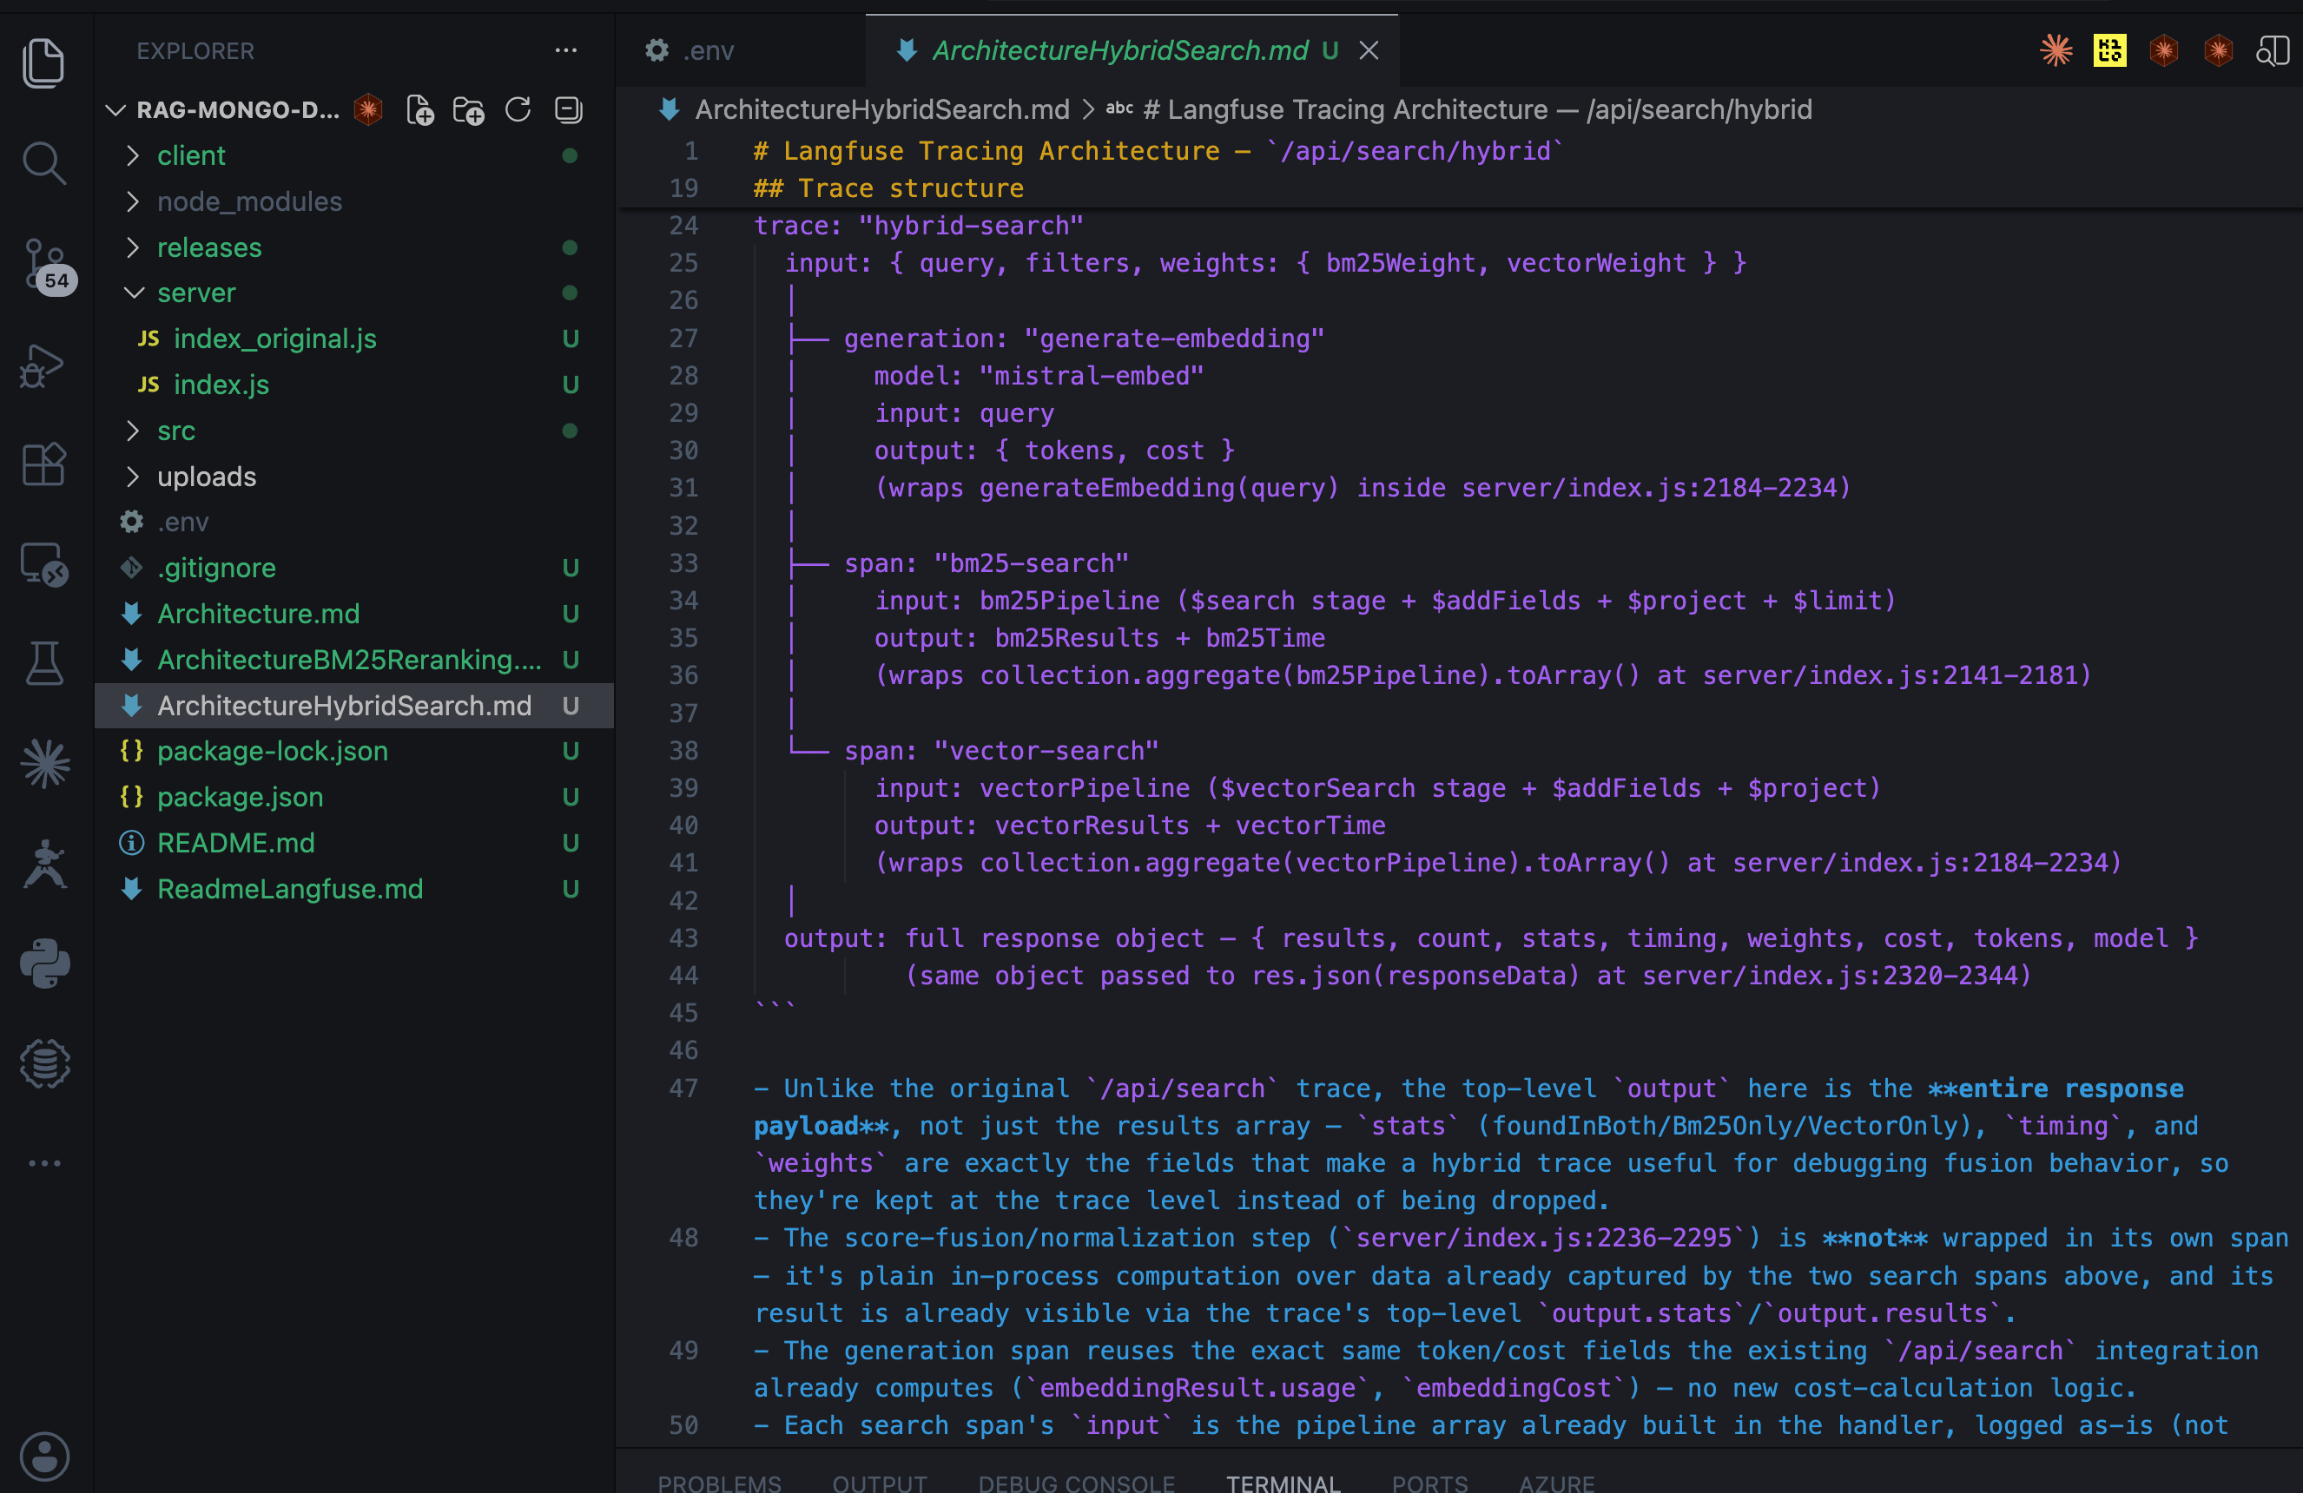
Run the Application and perform the actions to generate the Traces.
